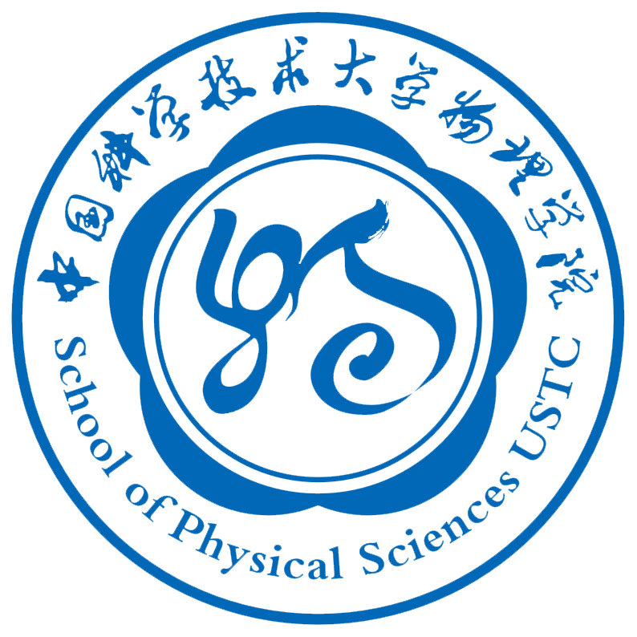

**Future Physicist International Summer Camp**

**----USTC 2015**

**Monday 6/29**

8:30am-9:00am Opening ceremony

Welcome from USTC vice president Chusheng Chen

9:30am-10:00am Students self-introduction

10:00am-11:00am Jiangfeng Du

“Spin-based Quantum Computation”

11:00am-12:00pm Junhua Yuan

“Bacterial motile behavior: from single motor to signaling network”

12:00-1:30pm Lunch

2:00pm-3:00pm Du Lab tour

3:30pm-5:00pm Chinese(汉语课)

**Tuesday 6/30**

8:30am-9:30am Minxin Huang

"String theory and its applications"

9:30am-9:45am Tea/Coffee Break

9:45am-10:45am Xuan Sun

“Introduction to Plasma Physics ”

10:45am-11:00am Tea/Coffee Break

11:00am-12:00pm Linfan Zhu

“The previous existence and present status of Compton scattering  — the exploration of electronic sturctures of atom and molecule by x-ray scattering technique”

12:00-1:30pm Lunch

2:00pm-2:50pm Sun Lab tour

3:00pm-3:50pm Zhu Lab tour

7:00pm-8:30pm  Chinese classical music performance（中古典音乐赏析）

**Wednesday 7/1**

8:30am-9:30am Zhe Sun

“Probing the electronic structures of solids by angle-resolved photoemission spectroscopy”

9:30am-9:45am Tea/Coffee Break

10:00am-11:00pm Zhensheng Yuan

“Quantum Information Processing with Photons and Atoms”

12:00-1:30pm Lunch

2:00pm-3:00pm Yuan Lab tour

3:30pm-5:00pm Chinese(汉语课)

**Thursday 7/2**

8:30am-9:30am Jin Zhao

“To see a world in a grain of sand, and a heven in a wild flower ---- An introduction to condensed matter physics”

9:30am-9:45am Tea/Coffee Break

9:45am-10:45am Haiping Peng

“A brief introduction of current High Energy Physics Experiment”

10:45am-11:00am Tea/Coffee Break

11:00am-12:00am Chuanfeng Li

“Quantum entanglement network and quantum physics”

12:00-1:30pm Lunch

2:00pm-3:00pm Peng Lab tour

3:00pm-4:00pm Li Lab tour

4:00pm-5:00pm JunhuaYuan Lab Tour

7:00pm-8:30pm Chinese Martial Arts(武术)

**Friday 7/3**

8:30am-9:30am Zhenhua Qiao

“Hall-Effect and Future Dissipationless Electronics”

9:30am-9:45am Tea/Coffee Break

9:45am-10:45am Wei Yi

"The world of ultracold atoms"

10:45am-11:00am Tea/Coffee Break

11:00am-12:00pm Yongquan Xue

“Lifting the Veil of Deeply Buried Supermassive Black Holes In the Universe”

12:00-1:30pm Lunch

2:00pm-3:00pm Briefing for Yellow Mountain trip

3:30pm-5:00pm Chinese (汉语课)

/

**7/4-7/5 Yellow Mountain tour**

**7/6-7/10: Research in individual research groups**

**7/11: Oral presentations; closing ceremony(8:30am)**